SIMATS ENGINEERING
ASSESSMENT TOOL 1

Experiments

COURSE NAME: Computer Networks COURSE CODE: CSA0704

COURSE OUTCOME COVERED

CO3: Analyze the performance of core network protocols such as TCP, UDP, HTTP, and DNS under varying conditions
Assessment Tool Weightage: 40%
SOFTWARE: CISCO PACKET TRACER, WIRESHARK

EXPERIMENTS

QUESTIONS:4 Total Marks:40

- Design a simple LAN consisting of two PCs connected through a switch using Cisco Packet Tracer. Configure appropriate IP addresses for both hosts and verify connectivity using the ping command. Simultaneously capture the packet exchange using Wireshark. Identify the Ethernet frame fields such as Source MAC Address, Destination MAC Address, EtherType, and Frame Check Sequence (FCS). Explain how the Data Link layer uses MAC addressing to ensure successful frame delivery within the local network.
Sol:
Aim:
To design a simple LAN consisting of two PCs connected through a switch using Cisco Packet Tracer, configure IP addresses, verify connectivity using the ping command, and analyze the Ethernet frame using Wireshark by identifying the Source MAC Address, Destination MAC Address, EtherType, and FCS.

Procedure:
- Open Cisco Packet Tracer.
- Place two PCs (PC0 and PC1) and one 2960 switch in the workspace.
- Connect PC0 and PC1 to the switch using Copper Straight-Through cables.
- Configure PC0 with:
  - IP Address: 192.168.1.1
  - Subnet Mask: 255.255.255.0
- Configure PC1 with:
  - IP Address: 192.168.1.2
  - Subnet Mask: 255.255.255.0
- Open the Command Prompt of PC0 and execute:
ping 192.168.1.2
- Verify that all four packets are successfully received.
- Open Wireshark and capture ICMP traffic generated by a ping.
- Apply the Wireshark display filter:
icmp
- Select an ICMP packet and expand Ethernet II.
- Identify the Source MAC Address, Destination MAC Address, and EtherType.
- Check whether the FCS field is available in the captured frame.
- Analyze how MAC addressing supports frame delivery within the LAN.

Implementation:
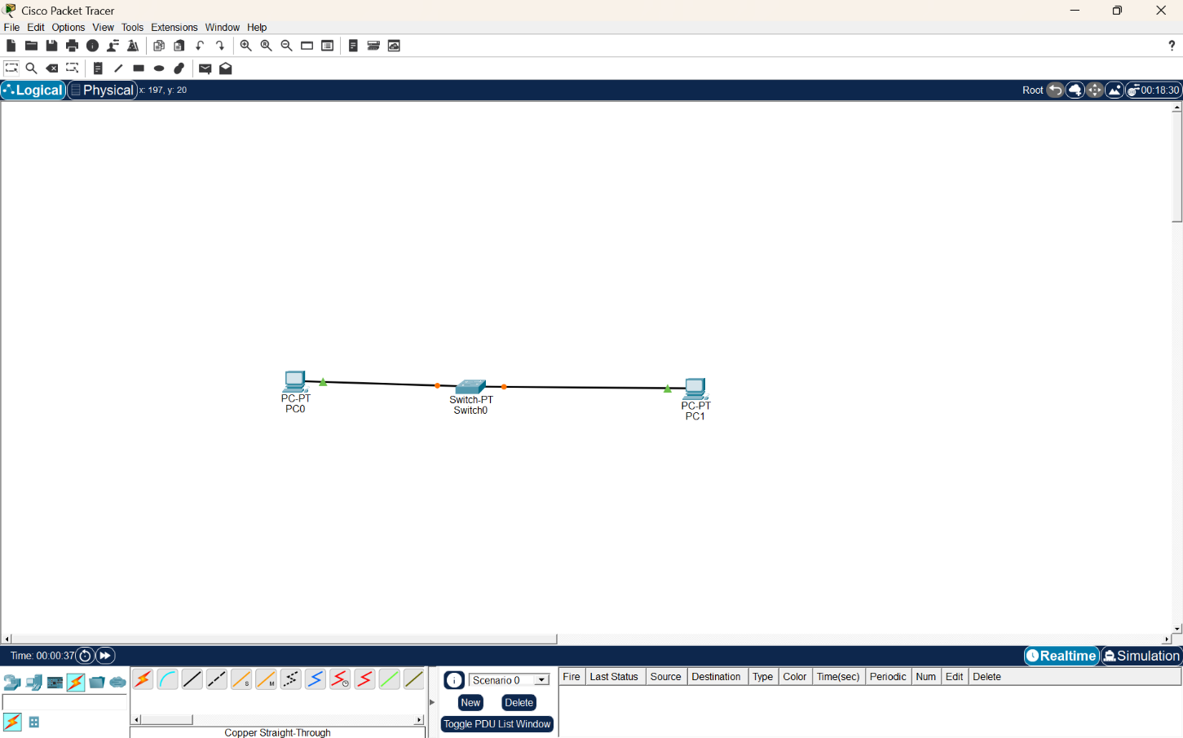
Screenshot 1 – LAN Topology
Figure 1: Simple LAN Topology Using a Switch
Explanation:
The topology consists of two PCs, PC0 and PC1, connected to a central switch. The switch provides communication between the two hosts within the same local area network.
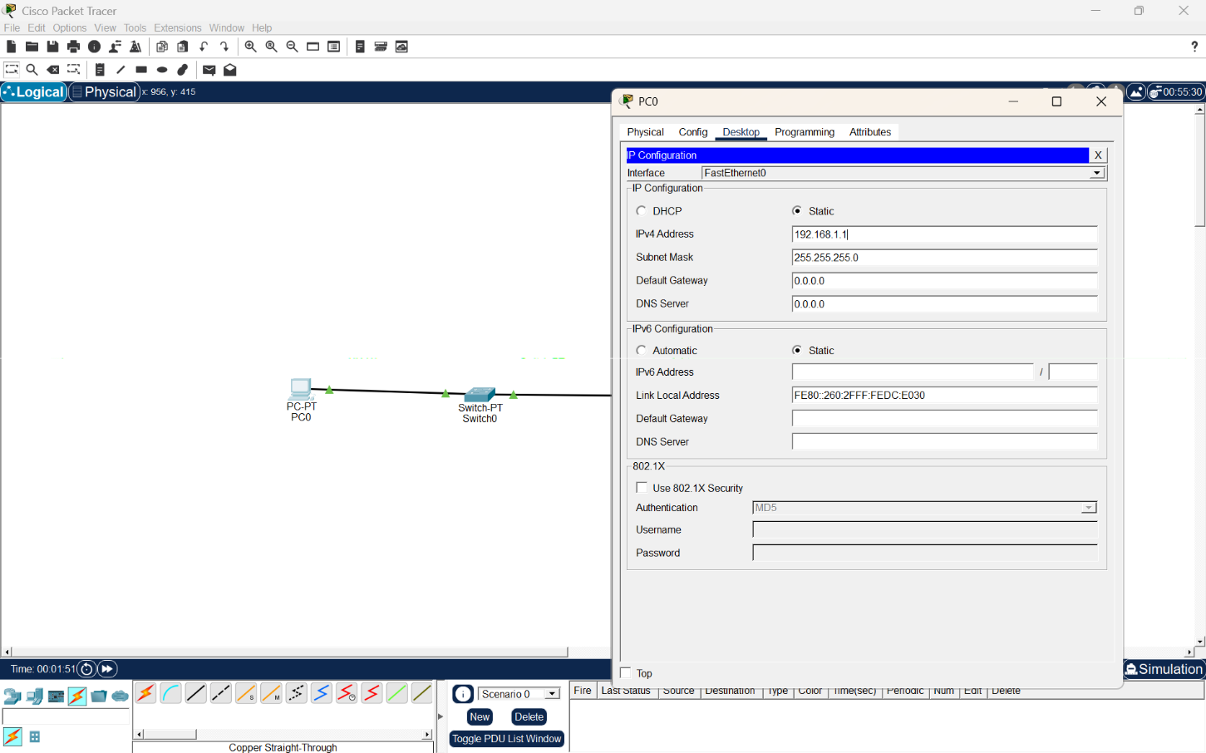
Screenshot 2 – PC0 IP Configuration
Figure 2: IP Configuration of PC0

Configuration:
Parameter | Value
IPv4 Address | 192.168.1.1
Subnet Mask | 255.255.255.0
Default Gateway | 0.0.0.0
Explanation:
PC0 is configured with the IP address 192.168.1.1 and subnet mask 255.255.255.0. Since PC0 and PC1 communicate within the same LAN, a default gateway is not required.

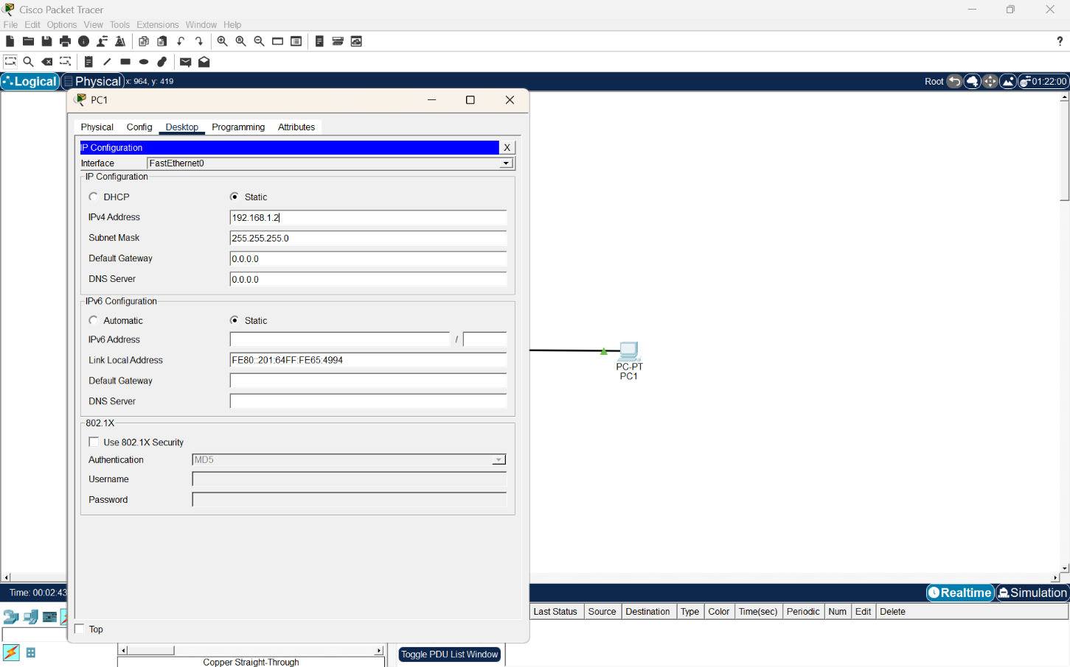
Screenshot 3 – PC1 IP Configuration
Figure 3: IP Configuration of PC1
Configuration:
Parameter | Value
IPv4 Address | 192.168.1.2
Subnet Mask | 255.255.255.0
Default Gateway | 0.0.0.0
Explanation:
PC1 is configured with the IP address 192.168.1.2 and subnet mask 255.255.255.0. Both PCs belong to the same subnet, allowing them to communicate directly through the switch.
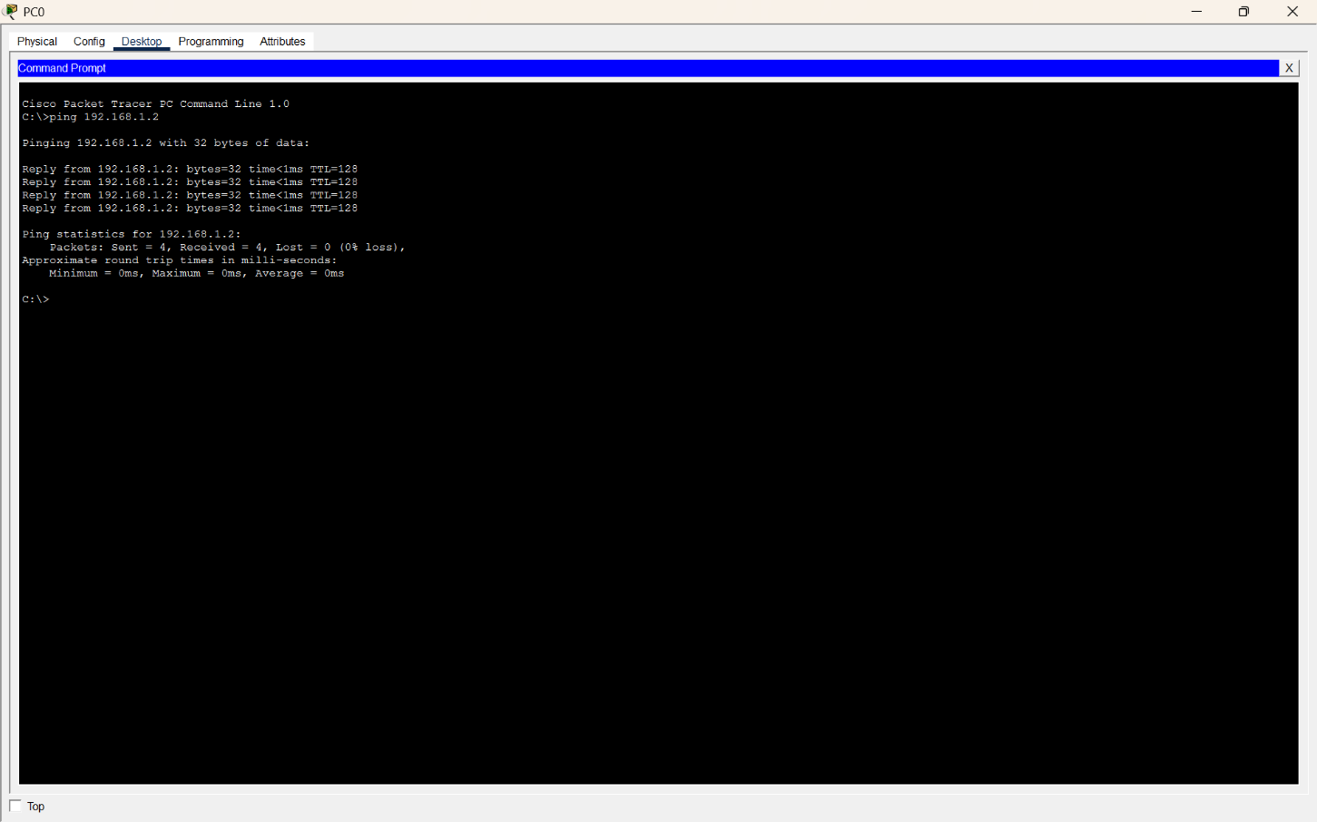
Screenshot 4 – Ping Verification
Figure 4: Successful Ping Between PC0 and PC1
Command:
ping 192.168.1.2
Result:
- Packets Sent = 4
- Packets Received = 4
- Packet Loss = 0%
- Average Response Time = 0 ms
Explanation:
The ping command successfully verifies connectivity between PC0 and PC1. All four packets were received successfully with 0% packet loss, confirming that the LAN configuration and connectivity are working correctly.

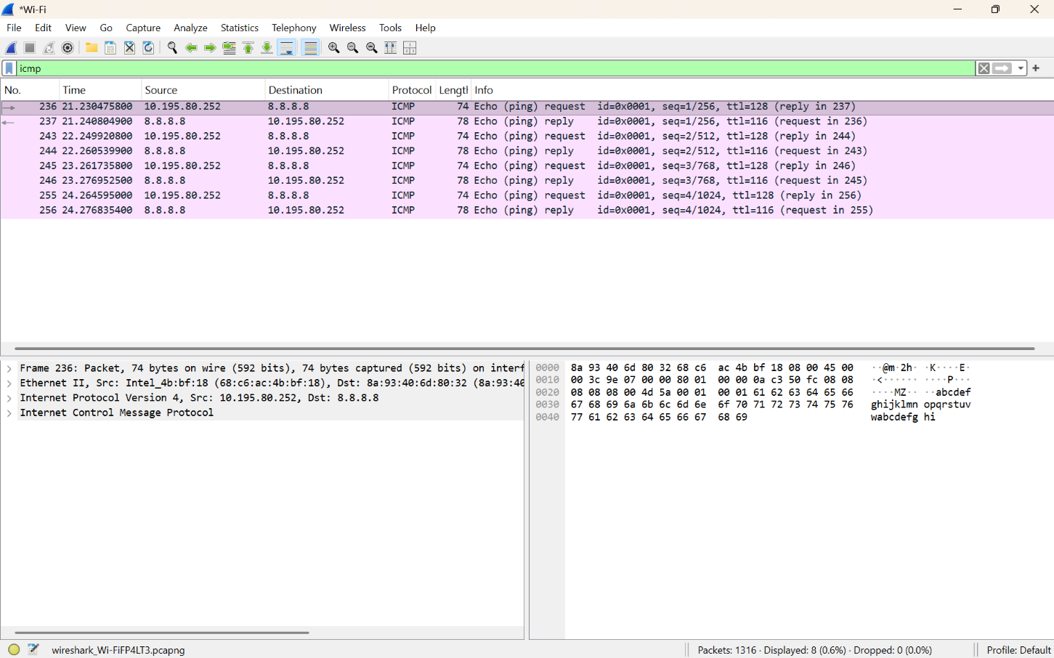
Screenshot 5 – Wireshark ICMP Capture
Figure 5: ICMP Packet Capture Using Wireshark

Explanation:
Wireshark captures the ICMP Echo Request and Echo Reply packets generated by the ping operation. The packet capture shows the communication between the local host and the destination 8.8.8.8. The packet contains the Ethernet II, IPv4, and ICMP protocol layers.

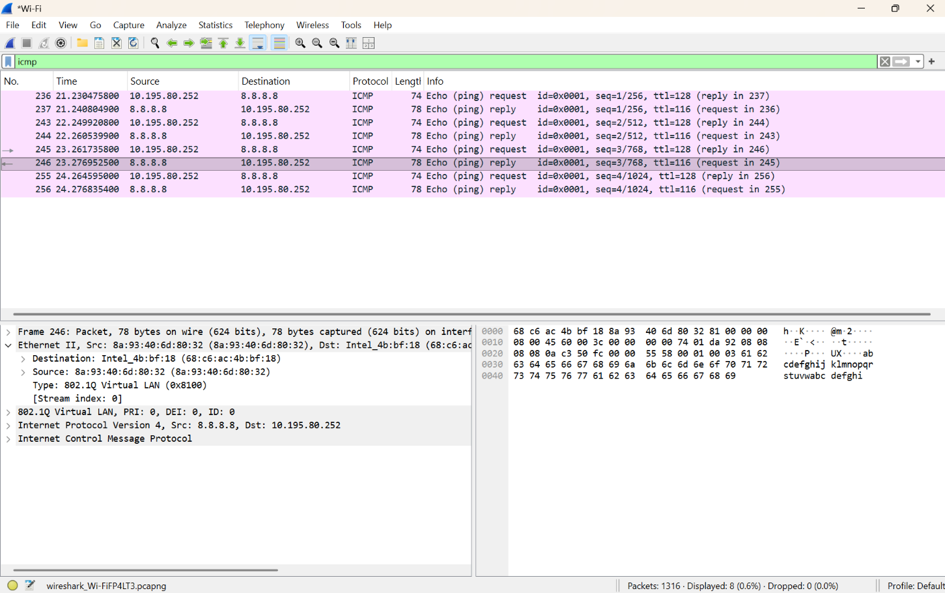
Screenshot 6 – Ethernet Frame Analysis

Figure 6: Ethernet Frame Fields in Wireshark

From the captured frame:
Field | Observed Value
Destination MAC | 68:c6:ac:4b:bf:18
Source MAC | 8a:93:40:6d:80:32
EtherType | 0x8100
VLAN ID | 0
FCS | Not displayed in the capture
Explanation:
The Ethernet II header contains the source and destination MAC addresses used for frame delivery at the Data Link layer. The captured frame has EtherType 0x8100, indicating an 802.1Q VLAN-tagged frame. The VLAN ID shown in the capture is 0.The FCS (Frame Check Sequence) is an error-detection field used to detect corruption in an Ethernet frame. It is not displayed in this particular Wireshark capture, so no FCS value is reported.
Data Link Layer Analysis
The Data Link layer uses MAC addresses to deliver Ethernet frames within the local network. The source MAC identifies the device transmitting the frame, while the destination MAC identifies the intended device. The switch examines the destination MAC address and forwards the frame through the appropriate switch port. This enables successful communication between devices in the LAN.
Result
A simple LAN with two PCs connected through a switch was successfully designed and configured in Cisco Packet Tracer. PC0 and PC1 were assigned IP addresses 192.168.1.1 and 192.168.1.2, respectively. Connectivity was successfully verified using the ping command with 0% packet loss. Wireshark was used to capture ICMP traffic and analyze the Ethernet frame, including the Source MAC Address, Destination MAC Address, EtherType, and availability of the FCS field. The experiment demonstrates how the Data Link layer uses MAC addressing for successful frame delivery within a local network.

- Develop a simple network consisting of two PCs connected through a router in Cisco Packet Tracer. Configure the required IP addresses and test connectivity using the ping command. Capture the ICMP traffic using Wireshark and identify the Echo Request and Echo Reply messages. Examine important ICMP fields such as Type, Code, Identifier, and Sequence Number, and calculate the Round Trip Time (RTT). Discuss how ICMP assists in network troubleshooting and connectivity verification.
_{SOL:}
Aim:
To develop a simple network consisting of two PCs connected through a router, configure IP addresses, test connectivity using the ping command, and analyze ICMP Echo Request and Echo Reply messages using Wireshark.
Procedure :

- Open Cisco Packet Tracer and create a new workspace.
- Add devices:
  - 2 PCs → PC0, PC1
  - 1 Router → Router0
- Connect the devices using Copper Straight-Through Cable:
  - PC0 → Router0 G0/0
  - Router0 G0/1 → PC1
- Configure PC0:
  - IP Address: 192.168.1.2
  - Subnet Mask: 255.255.255.0
  - Default Gateway: 192.168.1.1
- Configure PC1:
  - IP Address: 192.168.2.2
  - Subnet Mask: 255.255.255.0
  - Default Gateway: 192.168.2.1
- Configure Router0 through CLI:
  - Enter Privileged EXEC Mode using enable.
  - Enter Global Configuration Mode using configure terminal.
  - Configure G0/0:
  - interface gigabitEthernet 0/0
  - ip address 192.168.1.1 255.255.255.0
  - no shutdown
- exit
  - Configure G0/1:
  - interface gigabitEthernet 0/1
  - ip address 192.168.2.1 255.255.255.0
  - no shutdown
- exit
  - Use end to exit configuration mode.
- Verify router interfaces using:
show ip interface brief
  - Both interfaces should show up/up.
- Test PC0 to Router0 connectivity:
  - Open PC0 → Desktop → Command Prompt.
  - Enter:
ping 192.168.1.1
  - Check for Reply messages.
- Test PC0 to PC1 connectivity:
ping 192.168.2.2
  - Successful Echo Reply confirms connectivity.
- Test PC1 to PC0 connectivity:
ping 192.168.1.2
- Enable Simulation Mode in Packet Tracer:
  - Change Realtime → Simulation.
  - Click Edit Filters.
  - Select ICMP only.
- Generate ICMP traffic by running:
ping 192.168.2.2
- Click Capture/Forward to observe the ICMP packet travelling:
PC0 → Router0 → PC1
- Observe the ICMP Echo Request:
  - Type = 8
  - Code = 0
  - Identifier identifies the request.
  - Sequence Number identifies the order of the request.
- Observe the ICMP Echo Reply travelling back:
PC1 → Router0 → PC0
  - Type = 0
  - Code = 0
  - Identifier matches the request.
  - Sequence Number corresponds to the request.
- For Wireshark analysis, capture the ICMP packets on a supported real/virtual network interface and apply the filter:
icmp
- Calculate Round Trip Time (RTT):
RTT = Echo Reply Time − Echo Request Time
RTT represents the time taken for the packet to travel to the destination and back.
- Analyze ICMP for troubleshooting:
  - Ping checks connectivity.
  - Echo Request/Reply verifies reachability.
  - RTT measures network delay.
  - Packet loss can indicate network problems.
  - Helps identify problems with IP addresses, interfaces, cables, routing, and connectivity.
- Record the results of:
  - IP configuration
  - Ping responses
  - ICMP Echo Request
  - ICMP Echo Reply
  - Type and Code
  - Identifier and Sequence Number
  - RTT
- Conclude that ICMP is useful for network connectivity verification, delay measurement, packet-loss detection, and network troubleshooting.
Q1.Create a network with 2 PCs connected through 1 router in Cisco Packet Tracer.
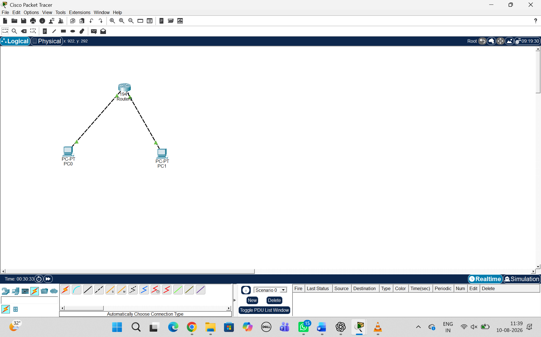

EXPLANATION:
First, open Cisco Packet Tracer and create a new project. Add two PCs (PC0 and PC1) and one router (Router0) to the workspace. Connect PC0 to Router0 G0/0 and PC1 to Router0 G0/1 using Copper Straight-Through cables. The final network topology will be PC0 → Router0 → PC1. This allows the two PCs to communicate with each other through the router.

Q2.Configure the required IP addresses, subnet masks, and default gateways for both PCs and the router.
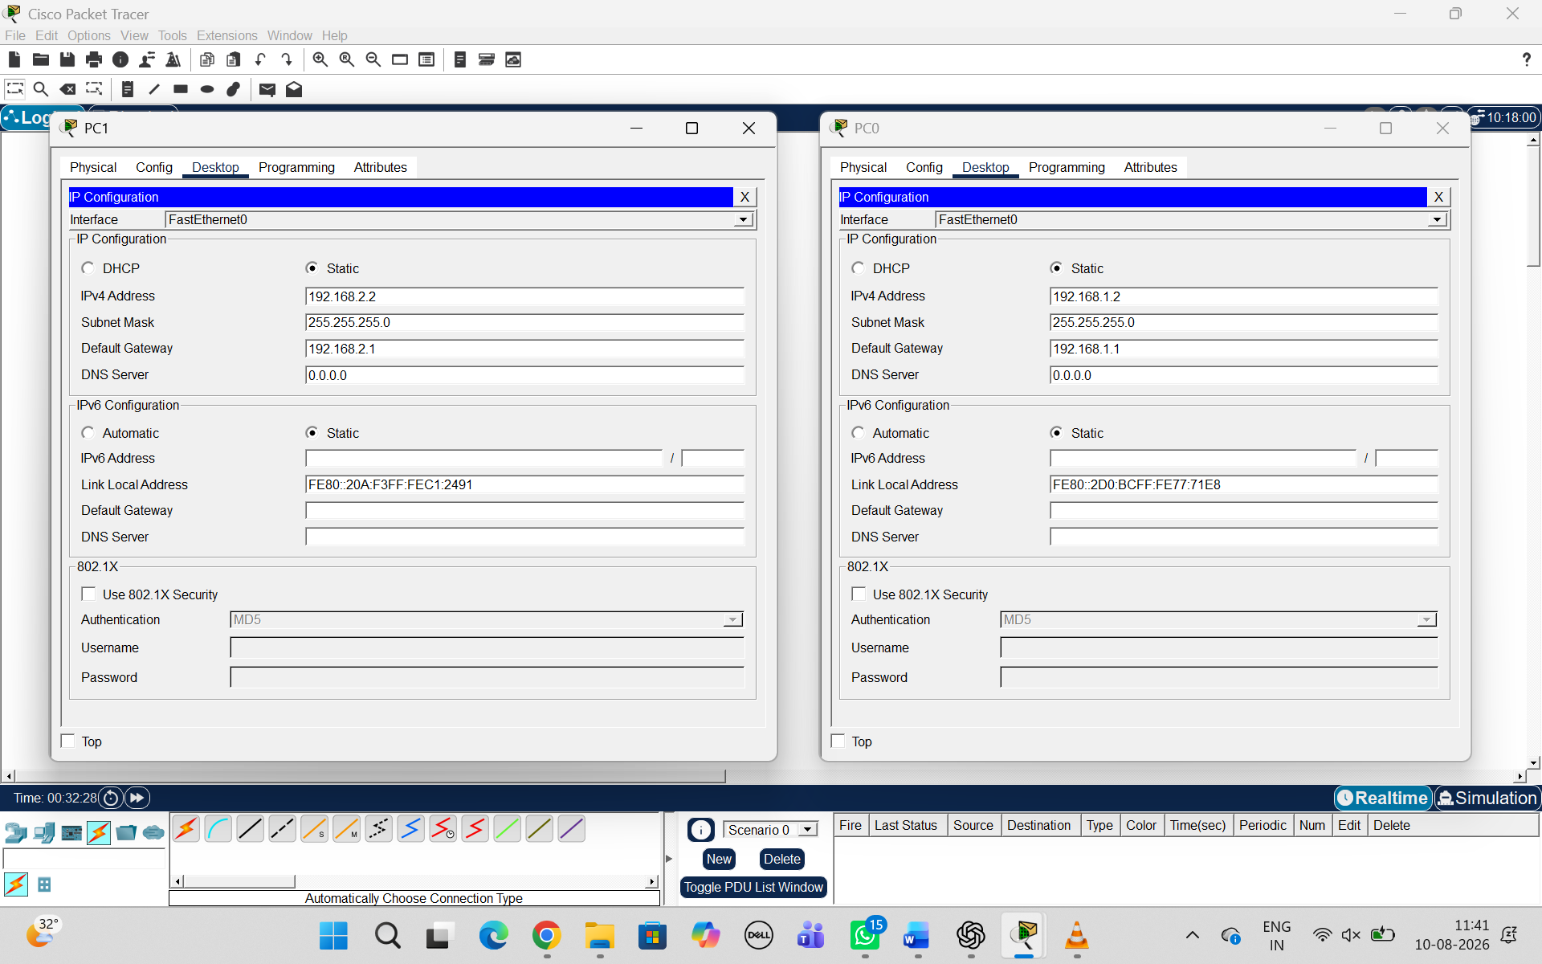

Device | Interface | IP Address | Subnet Mask
PC0 | FastEthernet0 | 192.168.1.2 | 255.255.255.0
Router0 | G0/0 | 192.168.1.1 | 255.255.255.0
Router0 | G0/1 | 192.168.2.1 | 255.255.255.0
PC1 | FastEthernet0 | 192.168.2.2 | 255.255.255.0

EXPLANATION:
Configure the IP addresses of all devices so that communication can take place between the two different networks. Assign 192.168.1.2 to PC0 with subnet mask 255.255.255.0 and gateway 192.168.1.1. Configure Router0 G0/0 as 192.168.1.1 and G0/1 as 192.168.2.1. Finally, assign 192.168.2.2 to PC1 with subnet mask 255.255.255.0 and gateway 192.168.2.1.

Q3.Use the ping command to verify connectivity between the PCs.
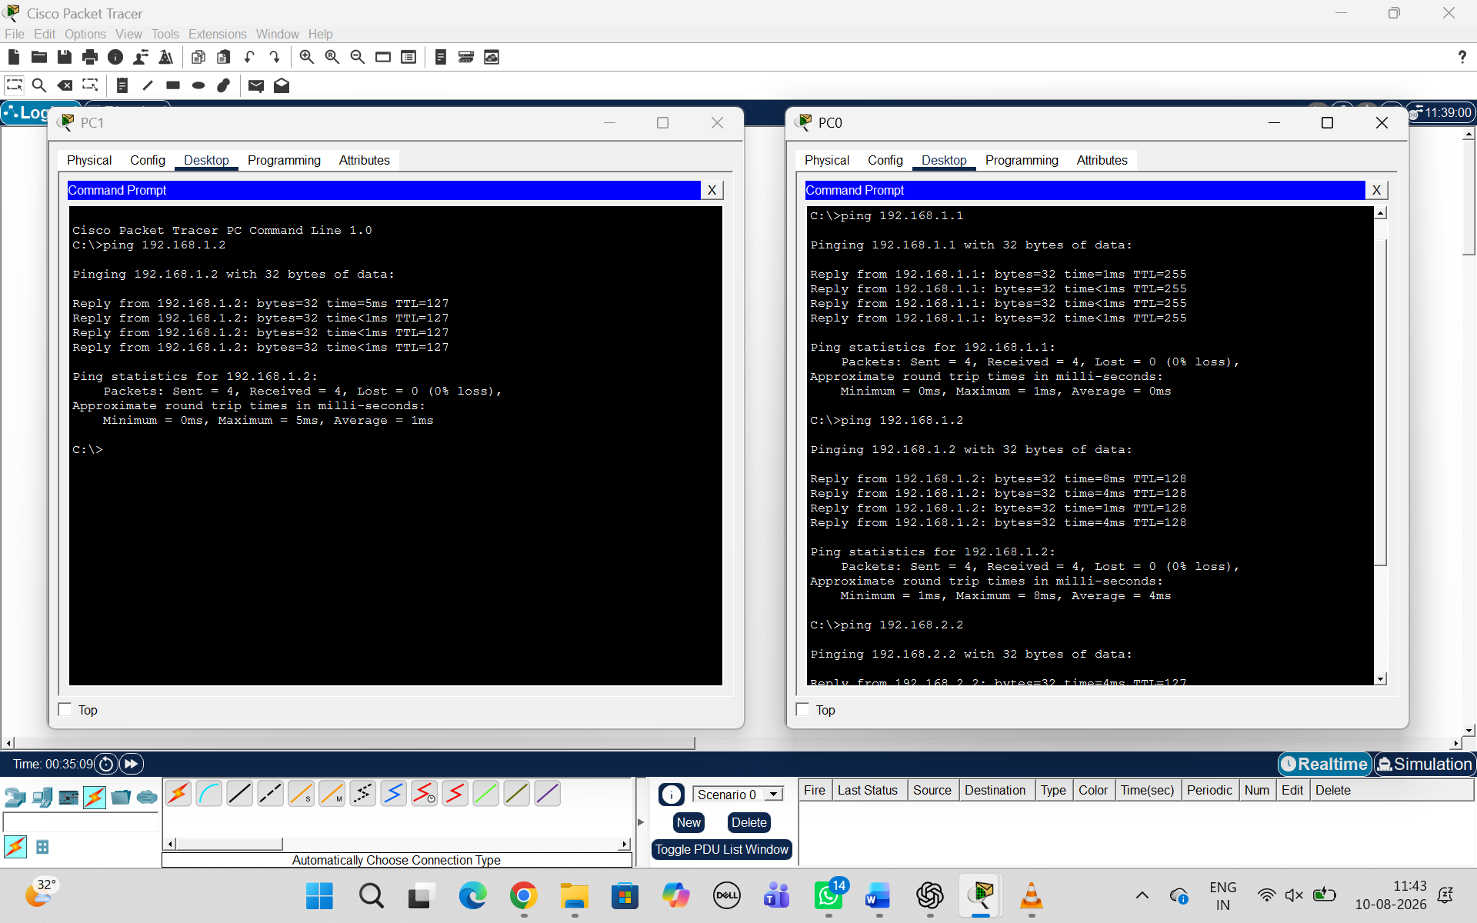
EXPLANATION:
After configuring the IP addresses, test whether the devices can communicate with each other using the ping command. Open PC0 → Desktop → Command Prompt and enter ping 192.168.2.2. The ping sends an ICMP Echo Request from PC0 to PC1, and PC1 sends an ICMP Echo Reply back to PC0. If the message shows Reply from 192.168.2.2, the connection is working successfully.
Q4.Capture/examine ICMP traffic and identify:
- Echo Request , Echo Reply , Type , Code , Identifier and Sequence Number
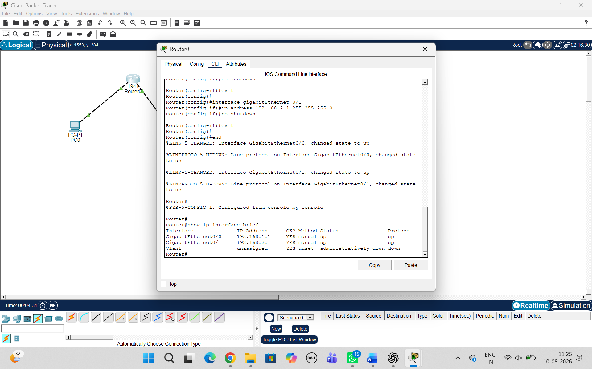

Field | Meaning
Type | 8 = Echo Request
Code | 0
Identifier | Identifies the ping request
Sequence Number | Number of the ICMP request

EXPLANATION:
Change Cisco Packet Tracer from Realtime Mode to Simulation Mode and select ICMP from the filters. Run the ping command and use Capture/Forward to observe the ICMP packets moving through the network. The Echo Request has Type 8 and Code 0, while the Echo Reply has Type 0 and Code 0. The Identifier identifies the ping process, and the Sequence Number identifies the order of each ICMP request and its corresponding reply.

Q5.RTT & Troubleshooting
- Calculate Round Trip Time (RTT)
- Explain how ICMP helps in network troubleshooting and connectivity verification.
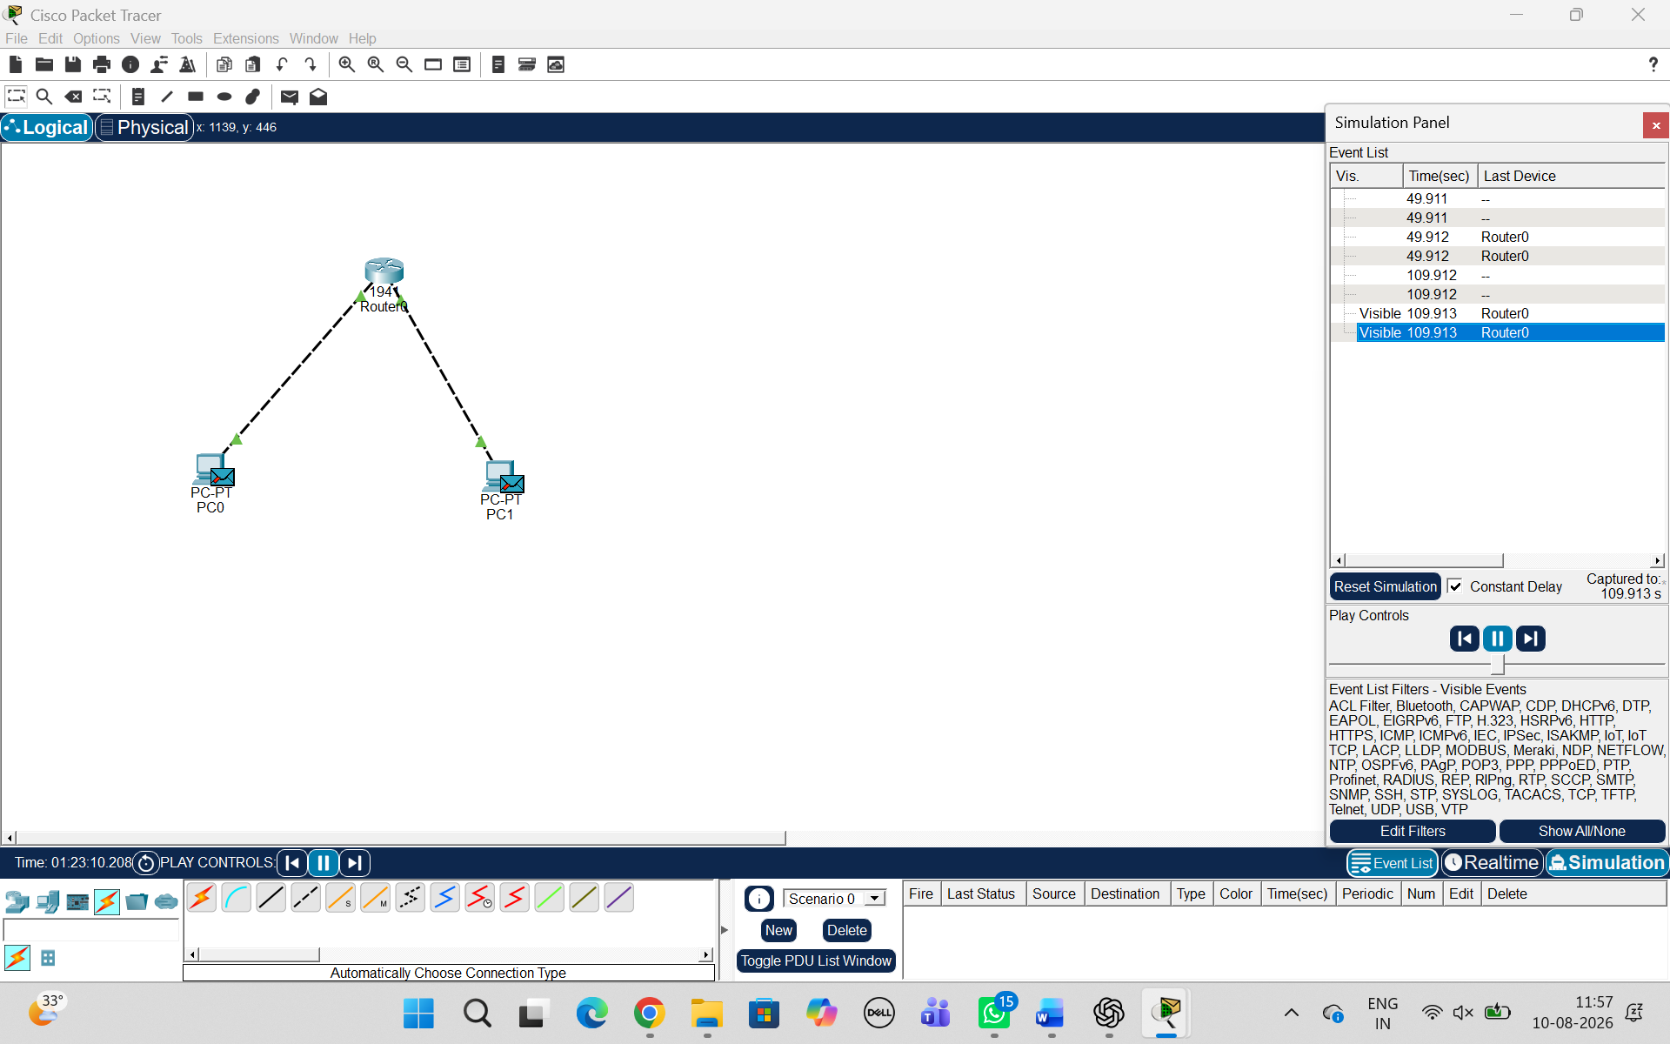

RTT Calculation
RTT = Echo Reply Time − Echo Request Time Calculation:
RTT = 49.912 − 49.911
= 0.001 seconds
Converting seconds into milliseconds:
RTT = 0.001 × 1000
= 1 ms
Answer
RTT = 1 ms

EXPLANATION:
RTT (Round Trip Time) is the time taken by an ICMP packet to travel from the source PC to the destination PC and for the reply to return to the source. It can be calculated as RTT = Echo Reply Time − Echo Request Time. A ping test can also identify packet loss, network delay, and connectivity problems. Therefore, ICMP is an important troubleshooting tool for checking IP configuration, router interfaces, routing, device reachability, and overall network connectivity.

RESULTS:

RUBRICS FOR CALCULATION

Criteria | Weightag e | Level 4 – Exemplary | Level 3 – Proficient | Level 2 – Developing | Level 1 – Beginning
Understandin g of Concepts | 25 | Demonstrates thorough understanding and effectively integrates multiple  concepts/technologi es | Good understanding with proper integration of most concepts | Basic understanding  ; limited or partial integration | Poor understanding  ; unable to integrate concepts
Experimental Design | 30 | Well-planned, systematic implementation with optimal solution | Correct implementati on with minor issues | Basic implementati on with errors or inefficiencies | Incorrect or incomplete implementati on
Use of Tools | 20 | Effective and advanced use of tools/technologies with proper configuration | Appropriate use of tools with correct execution | Limited or inconsistent use of tools | Incorrect or minimal use of tools
Analysis of Results | 15 | Insightful analysis with accurate interpretation and validation of results | Good analysis with reasonable interpretation | Basic analysis with limited insights | Poor or incorrect analysis of results
Documentati on | 10 | Clear, well-structured documentation with diagrams, code, and results | Organized documentatio n with necessary details | Basic documentatio n with missing details | Poor or incomplete documentatio n

